- Log in and navigate to your region.
Myunisa > Home/Student Support & Regions> Regional centres>
- Open the announcements channel.
- You will get a list of announcements, Click New content on the ribbon to add a new announcemnt.
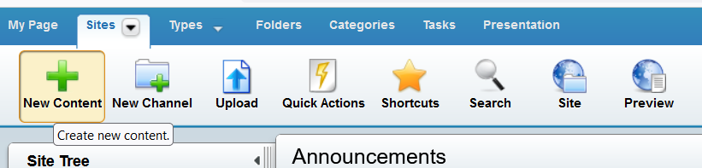

- Select the Unisa announcement content type.
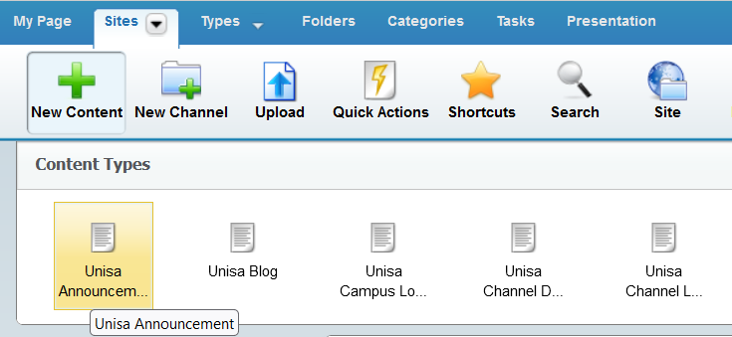

- Complete the required fields with a (*) and SAVE (that will prompt the folder structure)
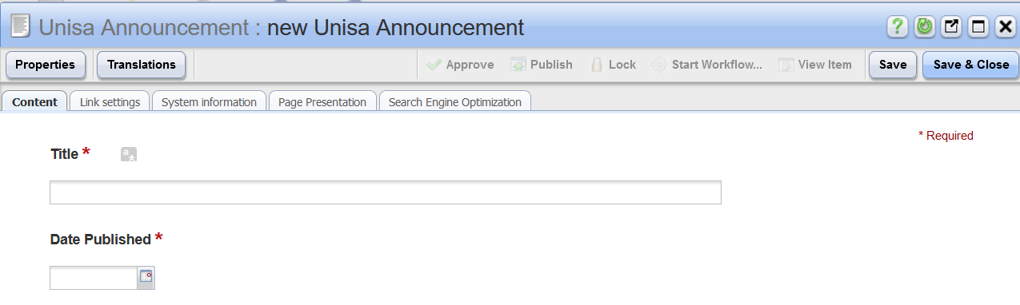

Save on the correct folder
- On the folder structure that appears, navigate to the correct folder (select your region)

- Inside the region’s folder, Click the announcement folder
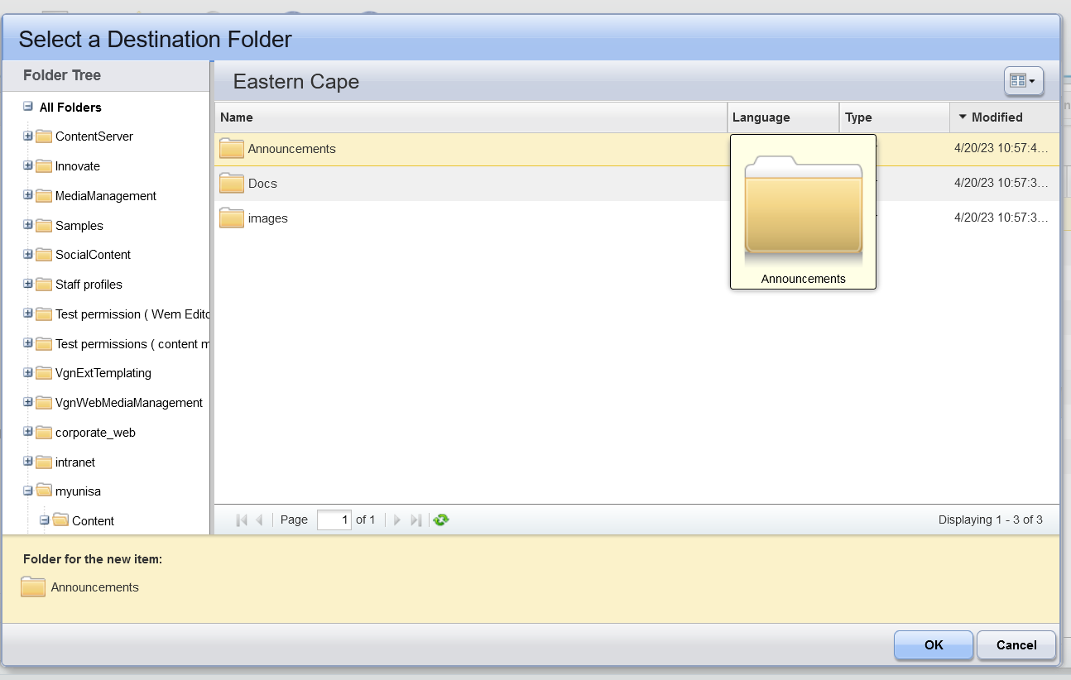
- At the bottom it must indicate the correct selected folder and Click OK

Adding content on the page

(Use the body section of the content instance and follow the steps on how to add content from page 9 onwards)

Linking documents
- Click Link setting tab and select content instance.
- Click create and click file

- Then follow the steps of adding a document on the main manual on page 32 to 36 of the WEM Manual.
Assigning a category
(This will place the announcement on the homepage of the region’s website)

- On the top right, Click the Properties tab
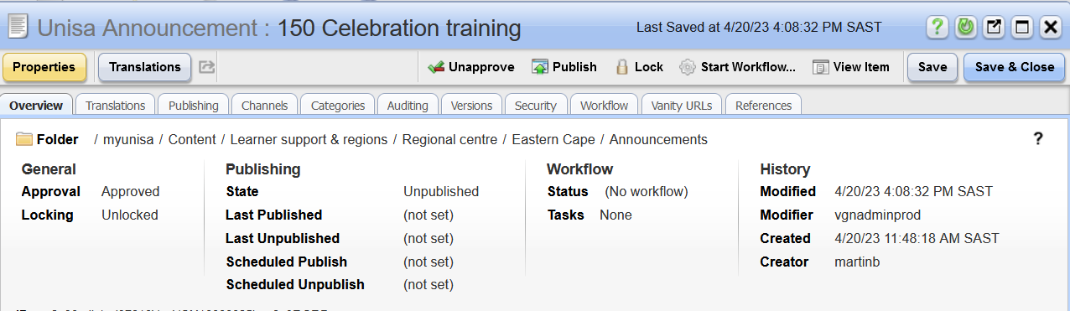
- Click Categories tab

- Click Add Categories

- Select the appropriate Category for your Region.

- Click add to selection and Click OK.

Workflow to submit for publishing
- Start the process of the workflow as on page 44 – 47 of WEM training Manual.

- END -

